**INFORMATICS PRACTICES**

**PROJECT REPORT ON FOOD ADULTERATION**

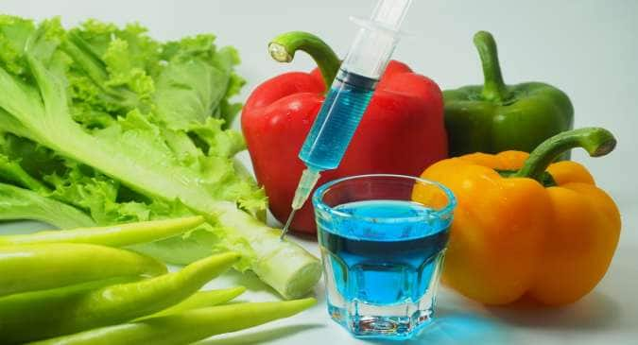

**SUBMITTED BY:** CATHLEEN E.D CHRIS

**PREPARED BY:**

KEERTHANA S

SIMON NICANOR

CATHLEEN E.D CHRIS

ADHITHI MANOLIN

ARAVINDH S

**GUIDED BY:**

MRS.JINCY M NELSON

(PGT INFORMATICS PRACTICES)

**THE HIGH RANGE SCHOOL, MATTUPATTI (AFFLIATED TO CBSE)**



**CERTIFICATE**

This is to certify that the project entitled ‘**FOOD ADULTERATION**’ is the record of bonafide project work carried out by **CATHLEEN E.D CHRIS** Reg no:____________________ for the partial fulfilment of class XII(AISSCE) CBSE syllabus requirement in the laboratory of this school during the academic year 2023-2024 in Informatics Practices.

Date:

INTERNAL GUIDE PRINCIPAL

(MS. JINCY M NELSON) (MS. VIJAYALAXMI S KAIMAL)

**ACKNOWLEDGEMENT**

We would like to express our sincere gratitude to our Principal, Mrs.Vijayalaxmi S Kaimal, Vice Principal, Mrs.Gladys Arooja who gave us support and encouragement all through the successful completion of this project.

We are very thankful to our guide and Informatics Practices teacher Mrs.Jincy M Nelson for her vital support, guidance and encouragement without which this project would not come forth from our side and for helping us in completing the project by giving ideas, thoughts and making this project easy and accurate.

We also thank our parents for their undivided support and interest who inspired us and encouraged us, without which we wouldn’t be unable to complete our project.

**INDEX**

|  |  |  |
| --- | --- | --- |
| **Sl no.** | **Topic** | **Page no.** |

**INTRODUCTION**

Food is a fundamental part of life, providing essential nutrients and energy needed for growth, health, and overall well-being. Beyond its basic biological function, food also plays a central role in culture, tradition, and social connection. From diverse culinary practices around the world to the bonds formed over shared meals, food is a source of joy and nourishment. Its significance extends to the global economy, sustaining livelihoods and fostering community ties.

However, food adulteration has emerged as a growing concern, threatening both the safety and quality of what we consume. Food adulteration refers to the intentional lowering of food standards for financial gain, often compromising health and consumer trust. This practice, known as Economically Motivated Adulteration (EMA), frequently involves misrepresenting ingredients, origins, or the composition of food products. High-value items, such as oils, spices, and beverages, are particularly susceptible to fraud, driven by profit margins and market pressures.

Over the years, numerous cases of food adulteration have caused serious health risks and even fatalities. Incidents like the contamination of cooking oil in China, the substitution of spices with harmful dyes, and methanol poisoning in Malaysia are alarming examples. Adulterated products have led to widespread illnesses, hospitalizations, and deaths, highlighting the urgent need for stronger oversight and regulation. The financial toll is equally staggering, with the global food industry suffering billions of dollars in losses annually due to fraudulent practices.

To combat this issue, food safety authorities have developed advanced detection techniques, including chromatography, spectrometry, and DNA-based methods. Despite these technological advancements, challenges remain in enforcing regulations and bridging gaps between research and policy. Ensuring food integrity requires ongoing efforts in research, international collaboration, and stricter enforcement, as the fight against food adulteration continues to evolve with new forms of fraud emerging.

**OBJECTIVE**

The objective of this project is

To apply the programming Knowledge into a real- world situation/problem.

Write programs utilizing python modules and attributes

Apply object oriented programming principles effectively when developing Small to medium sized projects.

Presenting large sets of data in graphs, charts etc.